2020 02 25 NR Daily Log

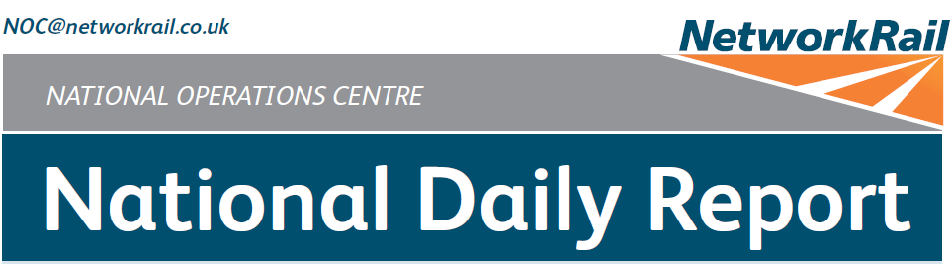



***DATE OF REPORT: NOC MANAGER 0700 – 1900:***

***NOC MANAGER 1900 – 0700:***

***DUTY CONTROLLER 0630 – 1830:***

***DUTY CONTROLLER 1830 – 0630:***

***SUPPORT CONTROLLER 0630 – 1830:***

***SUPPORT CONTROLLER 1830 – 0630:***

***LONDON CONTROLLER 0700 – 1900:***

***LONDON CONTROLLER 1900 – 0700:***

Tuesday 25th February 2020 Lucinda Wing

Mark Brown / Matthew Whitfield Bob Scoot

-

Peter Ure

-

Cornelius Edjah

-

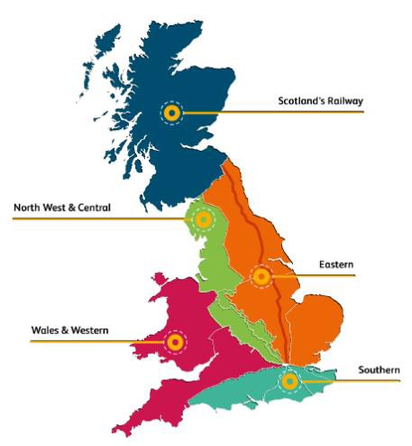

# TABLE OF CONTENTS

1. WRONG SIDE FAILURE REPORTS 3
2. SIGNALS PASSED AT RED (CATEGORY ‘A’) 3
3. DERAILMENTS 3
4. COLLISIONS 3
5. TRAIN OR VEHICLE RUNAWAY 3
6. OPERATIONAL INCIDENTS 3
7. TRAINS WITH STRANDED PASSENGERS 5
8. SIGNIFICANT POSSESSION PROBLEMS 5
9. FATALITIES 5
10. INJURIES/ASSAULTS 6
11. NEAR MISSES 6
12. RAILWAY CRIME 6
13. STATION OVERRUNS 6
14. BROKEN RAILS/TRACK DEFECTS 6
15. POWER FAILURES 7
16. POINTS FAILURES 7
17. SIGNALS/SIGNALLING SYSTEMS FAILURES 7
18. TRACK CIRCUIT & AXLE COUNTER FAILURES 7
19. BRIDGE STRIKES 8
20. ROAD VEHICLE INCURSIONS (NON-LEVEL CROSSINGS) 8
21. TRACTION FAILURES 8
22. WEATHER-RELATED PROBLEMS 9
23. FIRES 9
24. WILD REPORTS & HABD ACTIVATIONS 10
25. GROUP STANDARDS GE/RT8250 & GO/RT3350 11
26. TPWS 11
27. MISCELLANEOUS 11
28. REVIEW TABLE 12
29. REAL TIME PERFORMANCE FIGURES 13

## Eastern (East Coast) – CCIL 2100354 / Fault No. 788962

***01 WRONG SIDE FAILURE REPORTS***

At 1924, it was reported that after 4R55, Freightliner Cargo 1831 Drax Power station – Immingham Biomass LP, passed protecting signal D894, the exit barriers of Selby Road LC raised of their own accord. entry barriers remained in the lowered position. Faults with the level crossing barriers had been reported since Monday 24th February. In response to the most recent report, the crossing was placed under local control until testing could be completed, the results of which were unavailable at the close of this Report.

|  |  |  |  |  |  |  |  |
| --- | --- | --- | --- | --- | --- | --- | --- |
| TRUST 811587 OQIJ | | | | | | | |
| Cancelled | 0 | Part Cancelled | 0 | Trains Delayed | 11 | Minutes | 65 |

***02 SIGNALS PASSED AT RED (CATEGORY ‘A’)***

None.

***03 DERAILMENTS***

None.

***04 COLLISIONS***

None.

***05 TRAIN OR VEHICLE RUNAWAY***

None.

***06 OPERATIONAL INCIDENTS***

## Scotland – CCIL 2100463

At 0153 (Tue), the Shift Signalling Manager at Motherwell reported a Line Blockage irregularity of the Up and Down West Coast Main line between Beattock North and Elvan Water Viaduct whereby a train was signalled into the Line blockage. The limits of the Line blockage were of the Down line between CMC719 to GMC709 and the Up Main line between GMC612 and GMC718 signals. There were no staff on track when the irregularity took place. P’Way reported at 0210 that staff on site had been withdrawn on welfare grounds. It was determined that the signaller misunderstood the Line Blockage limits. The voice communications were downloaded and were found not to be of the required standard. ‘For cause’ screening was deemed unnecessary in this instance.

## Southern (Kent) – CCIL 2100493 / Fault No. 464822

At 0418, it was reported that 6J06, Balfour Beatty Rail Plant, 0455 Bickley Junction – Hither Green PAD had run through VS872 points at St Mary Cray Junction whilst exiting KS WON 48, item 9, Shortlands Junction – St Mary Cray Junction, Up and Down Chatham Slow lines blocked 0030 (Tue) – 0525 (Tue), a Kent IMDM managed possession. Investigations revealed that the points had been run through in the Normal position; the signaller realised the points had not been set to the correct position but was unable to advise the driver before the run-through occurred. The signaller was relieved of duty for interview and ‘for cause’ screening. S&T staff arrived on site at 0458 and reported at 0542 that there was significant damage to the point-work; the asset was consequently signed out of use. Owing to the run-through, trains booked on the Down Chatham Slow line were required to run on the Down Chatham Fast line from Bickley Junction to Swanley. A line blockage and isolation were in place by 1130 to allow repairs to commence. At 1453 it was reported that after the gear box had been removed it was found that the damage was worse than expected with both the left and right hand switches damaged, and a replacement half-set of switches would need to be ordered. Work continued to restore Normal detection, which was obtained at 1638, with the points secured. The line was reopened at 1719, after all personnel and equipment had been cleared. The points remain secured at start of service, Wednesday 26th February, with some Southeastern schedules amended in response.

|  |  |  |  |  |  |  |  |
| --- | --- | --- | --- | --- | --- | --- | --- |
| TRUST 811326 IQM1 | | | | | | | |
| Cancelled | 0 | Part Cancelled | 0 | Trains Delayed | 137 | Minutes | 856 |

## Eastern (EM) – CCIL 2100635 / Fault No. 154567

At 0948 the driver of 1D13, East Midlands Railway, 0834 London St. Pancras – Nottingham reported lateral and vertical movement on the Down Main line near Great Glenn old station, between Market Harborough and Leicester. P’Way staff were advised at 0952. At 1017, 1F15, East Midlands Railway, 0902, London St. Pancras – Sheffield, reported a movement in the same area. P’Way staff and the Mobile Operations Manager arrived on site from 1032, with the latter confirming that they had keyed signal LR241 signal to red at 1100. A member of P’Way staff stated at 1102 that they were awaiting a line blockage to carry out an inspection but were confident that the site would require lifting and packing, after which a 50mph ESR would be imposed. At 1136 a member of P’Way staff advised the lifting and packing work had been completed - a call was made at 1153 from a member of P’Way staff to a trainee signaller at Kettering, reportedly stating that all boards were in place and that the signaller could work normally, with drivers taking advice from the boards however at 1203, a maintenance technician called the signaller to report that the last train had gone through at line speed, when it should have been restricted to 50mph. At 1204 a member of P’Way staff stated that only the site boards were in place and that the warning boards and EROS still needed to be erected. The signaller then started cautioning trains at 50mph from signal LR225. Investigations – including voice comm practices – were ongoing at the close of this Report.

|  |  |  |  |  |  |  |  |
| --- | --- | --- | --- | --- | --- | --- | --- |
| TRUST 810375 IQVN | | | | | | | |
| Cancelled | 0 | Part Cancelled | 2 | Trains Delayed | 65 | Minutes | 486 |

## Eastern (Anglia) – CCIL 2100414

At 1317 a member of the Network Rail Route Health and Safety team working from Stratford Place reported unsafe working and a near miss with a group of P’Way staff working within a line blockage of platform 11 at Stratford Station. The near miss occurred at approximately 1153, when staff were working on an IBJ in platform 11. A member of P’Way staff put their leg over the 6ft rail as a train was approaching into platform

12. The member of staff confronted the P’Way and asked them to stop working. The P’Way stated that they were working a safe distance between where they were working and the train in platform 12. The P’Way Section Manager, appointed investigating officer, commenced an investigation into the incident and requested the screening for six members of staff. The train involved was identified as 2M21, Greater Anglia, 1138 Meridian Water – Stratford, and Forward Facing CCTV was requested.

## NW&C (WCMLS) – CCIL 2100841

At 1810, it was reported that the driver of 1M93, Cross Country, 1435 Exeter St David’s – Manchester Piccadilly had an operational incident on the Down line at WS6299 signal, near Rickerscote. The driver, who had continued to Stafford station before reporting it to the signaller, reported that they released the doors whilst at a stand at WS6299 signal, and that they were unsure as to whether any passengers alighted. Cross Country subsequently confirmed at 1814 that two sets of doors were opened by the public. Services were cautioned and confirmed that the line was clear. 1M93 was terminated on arrival at Stafford.

|  |  |  |  |  |  |  |  |
| --- | --- | --- | --- | --- | --- | --- | --- |
| TRUST 811122 FDBF | | | | | | | |
| Cancelled | 0 | Part Cancelled | 0 | Trains Delayed | 15 | Minutes | 152 |

***07 TRAINS WITH STRANDED PASSENGERS***

|  |  |  |  |  |  |
| --- | --- | --- | --- | --- | --- |
| ***Region / Route*** | ***Train*** | ***Since*** | ***Between*** | ***OUTCOME*** | ***CCIL*** |
| Eastern (North & East) | 2S70, Northern, 0638 Manchester Piccadilly - Sheffield | 0747 -  0910 | Totley Tunnel East – Dore West Junction | Mobile Operations Manager on site to clip points following a track circuit failure. The track circuit self-restored after the points were clipped up. | 2100580 |
| Eastern (North & East) | 1B66, TransPennine Express, 0653 Manchester Airport - Cleethorpes | 0758 -  0915 | Grindleford – Totley Tunnel East | As above. | 2100580 |
| Eastern (EM) | 1G16, CrossCountry, 0941  Nottingham – Birmingham New Street | 1018 -  1057 | Stenson Junction – North Stafford Junction | Erroneous reading from PLPR, train allowed to proceed after clarification. See also section **14** | 2100652 |
| W&W / Western | 1G21, Great Western Railway, 1528 London Paddington – Cheltenham | 1610 –  1657 | Swindon – Didcot | Train went forward after fatality at Swindon | 2100780 |
| W&W / Western | 1C20, Great Western Railway, 1532 London Paddington – Bristol Temple Meads | 1610 -  1645 | Swindon – Didcot | Train withdrawn to Didcot | 2100780 |
| W&W / Western | 1L24, Great Western Railway, | 1610 –  1710 | Chippenham – Swindon | Train authorised forward after incident train moved clear | 2100780 |

***08 SIGNIFICANT POSSESSION PROBLEMS***

None.

***09 FATALITIES***

## Wales and Western (Western) – CCIL 2100780

At 1610 the driver of 1A26, Great Western Railway, 1530 Bristol Temple Meads – London Paddington, reported that the train had struck a person on the Up Swindon Relief line at platform 3, Swindon. All lines were blocked, Emergency services and Network Rail staff attended at 1614. Platform 1 was reopened at 1630, allowing trapped services to be cleared. Services were diverted via Newbury. Replacement transport was provided in the form of coaches For Swindon, Chippenham and Didcot Parkway. BT Police (ref. 410) reported at 1638 that having obtained a statement from the driver, they had deemed the incident as non- suspicious. Undertakers arrived on site at 1645. Body recovery was completed at 1700, with all lines authorised to reopen at 1710 after all personnel were clear of the line. A relief driver was provided for 1A26 which was on the move as ECS at 1750. Samaritans signage and anti-trespass signs were confirmed as not in place at the specific location, though was on display in other areas of the station.

|  |  |  |  |  |  |  |  |
| --- | --- | --- | --- | --- | --- | --- | --- |
| TRUST 811218 XQDZ | | | | | | | |
| Cancelled | 34 | Part Cancelled | 16 | Trains Delayed | 168 | Minutes | 2163 |

None.

***11 NEAR MISSES***

## Eastern (Anglia) – CCIL 2100590

At 0826 the driver of 1F23, Greater Anglia, 0812 Braintree – Liverpool Street reported a near miss with a member of public at Cut Throat (Red/Green) Crossing on the Braintree Single line between White Notley and Witham. The member of public jumped the barriers and ran across as the train approached. The driver did not apply the emergency brake and was fit to continue. The British Transport Police were advised, (ref.137). The Mobile Operations Manager attended and reported all signage in place and the crossing was functioning correctly.

## Wales and Western (Wales) – CCIL 2100786

At 1626 the driver of 2E24, Transport for Wales, 1400 Swansea - Pembroke, reported a near miss at Beavers Hill Open Crossing, between Manorbier and Lamphey with a road vehicle which crossed as the train approached. The driver was fit to continue. All details were passed to the British Transport Police, with Mobile Operations Manager arranged to attend Wednesday morning.

***12 RAILWAY CRIME***

None.

***13 STATION OVERRUNS***

None.

***14 BROKEN RAILS/TRACK DEFECTS***

## Southern (Kent) – CCIL 2100684 / Fault No. 159612

At 1129 a broken rail was reported on the Chatham Reversible Line at Linford Street Junction at 1m 40ch, between London Victoria and Wandsworth Road, due to a vertical break in a weld. The line was blocked for P’Way examination. At 1200 P’Way confirmed a broken rail with the line blocked pending repairs. Clamps were fitted to the break, allowing the line to reopen at 1651 with a 20 mph ESR imposed and all warning boards in position. A replacement rail was installed overnight.

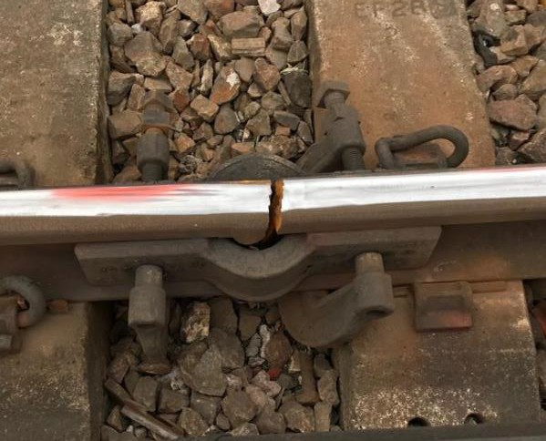

|  |  |  |  |  |  |  |  |
| --- | --- | --- | --- | --- | --- | --- | --- |
| TRUST 811218 ZQDZ | | | | | | | |
| Cancelled | 0 | Part Cancelled | 0 | Trains Delayed | 2 | Minutes | 7 |

None.

***16 POINTS FAILURES***

## Wales and Western (Western) – CCIL 2100691 / Fault No. 461555

At 1210 the Thames Valley Signalling Centre (Acton panel signaller) reported that they were unable to signal trains in and out of Acton yard due to having no detection on No.8139 points in the Reverse position. S&T were advised and were on site by 1234, advising at 1310 that there was no power going to the asset. The Mobile Operations Manager was requested and by 1315 had clipped the points in Reverse, allowing 6B78, DB Cargo, 1040 Brentford – Acton yard to enter the yard, after which a backlog of trains was cleared. S&T staff returned overnight, arriving on site at 2253 to continue with further testing, the results of which were not available as this Report closed.

|  |  |  |  |  |  |  |  |
| --- | --- | --- | --- | --- | --- | --- | --- |
| TRUST 810667 IQDR | | | | | | | |
| Cancelled | 0 | Part Cancelled | 2 | Trains Delayed | 56 | Minutes | 1941 |

***17 SIGNALS/SIGNALLING SYSTEMS FAILURES***

## Southern (Kent) – CCIL 2100924 / Fault No. 464928

At 2234 the driver of 2S78, Southeastern, 2204 London Charing Cross – Sevenoaks, reported that L315 signal on the Down Fast line at Grove Park had reverted to red as the train approached. The driver was unable to clarify the aspect offered prior to the signal reverting to red. Data interrogation indicated that the reversion was from single yellow to red. The driver was unable to stop and passed the signal at red by an unspecified distance. There was no apparent reason for the reversion, the driver was fit to continue to Orpington, where the service was cancelled.

|  |  |  |  |  |  |  |  |
| --- | --- | --- | --- | --- | --- | --- | --- |
| TRUST 812430 | | | | | | | |
| Cancelled | 0 | Part Cancelled | 2 | Trains Delayed | 13 | Minutes | 55 |

***18 TRACK CIRCUIT & AXLE COUNTER FAILURES***

## North West and Central (NW) – CCIL 2099989 / Fault No. 883274

With reference to the failure of track circuit ‘1396’ on the Up East line between Up East line between Ardwick and Ashburys in this section of yesterday’s Report: The track circuit was reported as intermittently showing occupied when clear. At 0856 the Manchester Piccadilly Shift Signalling Manager advised that the track circuit had ‘blipped’ five more times and that 3.5 working would remain in place, with trains passing signal MP312 at red. By 0943 the track circuit had ‘blipped’ a further 3 times, with 3.5 working still in place. S&T staff were on site and investigating by 0947. S&T staff advised at 1114 that they had found a track feed with a poor reading and had traced the probable cause to a joint that was full of water. Readings improved once the cable was rejointed at 1342 however due to 2 x 170 metre cables also having poor readings, it was agreed that cable replacement would need to be carried out by S&T staff. Replacement cable was rolled out trackside by 1820 and installed by 1912. The successful completion of cable testing confirmed a full restoration, with normal signalling, from 1955.

|  |  |  |  |  |  |  |  |
| --- | --- | --- | --- | --- | --- | --- | --- |
| TRUST 806858 IQFM | | | | | | | |
| Cancelled | 51 | Part Cancelled | 43 | Trains Delayed | 431 | Minutes | 3051  (since 24/02/20) |

## Eastern (North & East) – CCIL 2100580 / Fault No. 789009

At 0759 the Sheffield sub-ROC Shift Signalling Manager reported that track circuit 101 had failed after the passage of 1R52, East Midlands Railway, 0635 Nottingham – Liverpool Lime Street. This route locked Dore West Junction, holding signal S55 at red. Signal S58 was also held at red preventing trains being routed via the Up Main line to Dore West Junction. A block was put on to services from Manchester. S&T staff were advised at 0803 and the Mobile Operations Manager at 0807. 1B67, TransPennine Express, 0626 Cleethorpes – Manchester Airport, was used to examine the line but reported at 0828 nothing seen. An S&T fault team arrived on site at 0829. A Mobile Operations Manager was granted a line blockage to secure No.4028 points at 0850 in order to release two trapped trains, as detailed in section **07** of the Report. The signaller advised at 0909 that the track circuit had cleared, and the pointwork was unclipped in response.

|  |  |  |  |  |  |  |  |
| --- | --- | --- | --- | --- | --- | --- | --- |
| TRUST 810089 IQGL | | | | | | | |
| Cancelled | 2 | Part Cancelled | 14 | Trains Delayed | 92 | Minutes | 992 |

***19 BRIDGE STRIKES***

|  |  |  |  |  |  |  |  |
| --- | --- | --- | --- | --- | --- | --- | --- |
| ***Region / Route*** | ***Time*** | ***Location*** | ***Bridge No.*** | ***Dispensation*** | ***NWR*** | ***CCIL*** | ***TRUST*** |
| Southern  / Wessex | 0836 | Romsey | E9/30 | R | 0914 | 2100592 | 810283 XQCW= 1 trains = 31 mins. |
| North West and Central / WCMLS | 0955 | Stoke-On- Trent | Bridge 86 | DA | 1007 | 2100634 | 810353 XQNA= 12 trains = 78 mins. |
| Eastern (EM) | 1403 | Mansfield Woodhouse | PBS3/36 | A | 1533 | 2100734 | 811014 XQVD = 9 trains = 68 mins. |
| Eastern (EM) | 1514 | Longton | NSS/11 | R | 1533 | 2100758 | 811109 XQVD = 20 trains = 102 mins. |

***20 ROAD VEHICLE INCURSIONS (NON-LEVEL CROSSINGS)***

None.

***21 TRACTION FAILURES***

## Wales & Western (Wales) - CCIL 2100846

At 1841 passengers reported smoke coming from both the lighting and from underneath 2D64, Transport for Wales, 1748 Penarth – Bargoed, units 142010 & 143610. The smoke in vehicle 55643 resulted in passengers being moved into adjacent carriages. South Wales Fire Service met the train at Llanbradach, where the incident had been reported, though at 1911 advised that no trace of a fire had been found. A rolling stock technician authorised the train to continue as empty coaching stock to Canton Sidings at 1948. The RAIB were advised of the incident via N1 form 20/015 at 0054.

|  |  |  |  |  |  |  |  |
| --- | --- | --- | --- | --- | --- | --- | --- |
| TRUST 811666 | | | | | | | |
| Cancelled | 2 | Part Cancelled | 1 | Trains Delayed | 12 | Minutes | 272 |

## Wales & Western (Wales) - CCIL 2091559

At 1117 it was reported that due to rising floodwater under the Severn River bridge at Shrewsbury Station the routes through Shrewsbury Station would be blocked from 1400. Services from the North (Crewe and Wrexham) were able to terminate in the North end of the platforms and all other services terminated short for alternative road transport. The water levels were monitored and were reported to be rising throughout the afternoon, peaking at 1800 before slowly receding in the evening. A daylight inspection was pending as this Report closed.

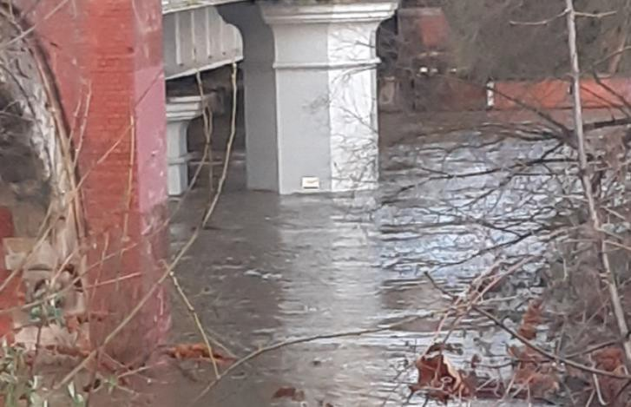

|  |  |  |  |  |  |  |  |
| --- | --- | --- | --- | --- | --- | --- | --- |
| TRUST 810657 XQWS | | | | | | | |
| Cancelled | 27 | Part Cancelled | 51 | Trains Delayed | 50 | Minutes | 444 |

***23 FIRES***

None.

## Disconnected Hot Axle Box Detectors:

|  |  |  |  |  |  |  |  |  |  |
| --- | --- | --- | --- | --- | --- | --- | --- | --- | --- |
| *Region / Route* | *Location* | *Line* | *Date Disconnected* | *Reason* | *TOC’s/ FOC’s*  *advised* | *Planned Restoration Date* | *Date Restored* | *Function* | *Fault Number* |
| Eastern (Anglia) | Brentwood | Down Electric | 10/03/16 | Offline | Y | Awaiting update |  | IM | 234632 |
| Eastern (Anglia) | Brentwood | Down Main | 10/03/16 | Offline | Y | Awaiting update |  | IM | 234632 |
| Eastern (Anglia) | Margaretting | Up Main | 19/09/19 |  | Y | Awaiting update |  | IM | 298498 |
| Eastern (EM) | Branston | Up Tamworth | 18/02/20 | Defective | Y | Awaiting update |  | IM | 154332 |
| Eastern (EM) | Chiltern Green | Down Slow | 11/07/19 | Defective | Y | Awaiting update |  |  | 148559 |
| Eastern (EM) | Napsbury | Up Fast | 11/07/19 | Defective | Y | Awaiting update |  |  | 148559 |
| Eastern (EM) | Langley Mill | Up & Down Erewash Slow | 13/02/20 | SK4 fault | Y | Awaiting update | 18/02/20 | IM | 1564199 |
| Eastern (LNE) | Barkston | Up Main | 01/04/19 | Removed for P’Way work | Y | Awaiting update |  |  |  |
| NW & Central (NW) | Bolton-le- Sands | Up Main | 25/08/19 | Integrity Fault | Y | Awaiting update |  |  | 863361 |
| NW & Central (NW) | Hest Bank | Up Main | 25/08/19 | Integrity Fault | Y | Awaiting update |  |  | 863360 |
| NW & Central (NW) | Low Mill | Down Main | 26/11/14 | Awaiting replacement | Y | Awaiting update |  | IP | 671852 |
| NW & Central (NW) | Sutton Weaver | Down Main |  |  | Y | Awaiting update |  |  |  |
| NW & Central (WCMLS) | Bradnocks Marsh (Coventry) | Up Main | 29/12/19 | Integrity | Y | Awaiting Update |  |  | 872142 |
| NW & Central (WCMLS) | Castlethorpe | Up Fast | 27/11/18 | Error code 6.0 | Y | Awaiting Update |  | IM | 832410 |
| NW & Central (WCMLS) | Harecastle | Up Main | 01/04/19 | Rail incorrectly drilled | Y | Awaiting Update |  |  |  |
| NW & Central (WCMLS) | Penkridge | Up Penkridge | 04/11/19 | Integrity | Y | Awaiting Update |  |  | 870982 |
| Wales & Western (Wales) | Dainton | Down Main | 17/11/19 | Defective PC | Y | Awaiting Update |  | IM | 453850 |
| Wales & Western (Wales) | Pembrey | Up | 17/02/20 | Constantly alarming | Y | Awaiting Update |  | IM | 460854 |
| Wales & Western (Western) | Cogload | Down Main | 25/01/20 |  | Y |  |  |  | 458740 |
| Wales & Western (Western) | Treverrin | Down Main | 01/07/19 |  | Y | Awaiting Update |  |  | 443474 |
| Wales & Western (Western) | Twerton | Down Main | 19/11/19 |  | Y | Awaiting Update |  |  | 454030 |
| Wales & Western (Western) | Warminster | Up Salisbury | 22/01/20 | Defective | Y | Awaiting Update |  |  | 458111 |

## Disconnected Wheel Impact Load Detectors:

|  |  |  |  |  |  |  |  |  |  |
| --- | --- | --- | --- | --- | --- | --- | --- | --- | --- |
| *Region / Route* | *Location* | *Line* | *Date Disconnecte d* | *Reason* | *TOC’s/ FOC’s*  *advised* | *Planned Restorat ion Date* | *Date Restore d* | *Function* | *Fault Number* |
| Eastern (EC) | Sessay | Up Slow | 18/06/2019 | Calibration |  |  |  | IM |  |
| North West & Central (NW) | Heaton Chapel | Up Slow | 30/07/2019 | Calibration |  |  |  | IM |  |
| Southern (Kent) | Sevington | Down Main | 25/04/2018 | PC Failure |  |  |  | IM |  |
| Southern (Kent) | Sevington | Up Main | 09/08/2018 | PC Failure |  |  |  | IM |  |
| Southern (Kent) | Swanley | Up Slow | 02/04/2019 | Calibration |  |  |  | IM |  |
| Scotland | Howwood | Up | 20/01/2019 | HOBC |  |  |  | IM |  |
| Wales & Western (Western) | Urchfont | Up | 11/04/2019 | PC Failure |  |  |  | IM |  |
| Wales & Western (Western) | Urchfont | Down | 11/04/2019 | PC Failure |  |  |  | IM |  |

***25 GROUP STANDARDS GE/RT8250 & GO/RT3350***

None.

***26 TPWS***

|  |  |  |  |  |  |  |  |  |
| --- | --- | --- | --- | --- | --- | --- | --- | --- |
| ***Region*** | ***Route*** | ***Train*** | ***Signal/PSR/ Buffer Stop*** | ***Line/Platform*** | ***Location*** | ***Speed (reported)*** | ***Speed (set)*** | ***CCIL*** |
| Eastern | Anglia | 2R15, Greater Anglia, 1228 Felixstowe - Ipswich | 9012 Signal | Felixstowe Single Line | Derby Road | 70 | 76 | 2100714 |
| Eastern | EM | 1D67, East Midlands Railway, 1512 Birmingham New Street – Nottingham | Signal TN4965 | Line C | Nottingham Mansfield Junction | 35 | 27.5 | 2100793 |
| NW&C | WCMLS | 2G53, Chiltern Railways, 18:04 Marylebone - Gerrards Cross | ME117 Signal | Down Main | Gerrards Cross | 30 | 46 | 2100855 |

***27 MISCELLANEOUS***

## Eastern (EM) – CCIL 2100652

At 1015 the Down Tamworth line was blocked after the PLPR train reported three separate wide gauge issues. P’Way and S&T staff were advised. The track maintenance spoke to the PLPR on train manager at 1052 and established that the reading was erroneous due to sunlight on the laser, after which train running resumed.

|  |  |  |  |  |  |  |  |
| --- | --- | --- | --- | --- | --- | --- | --- |
| TRUST 810428 IQVN | | | | | | | |
| Cancelled | 2 | Part Cancelled | 1 | Trains Delayed | 25 | Minutes | 371 |

|  |  |  |
| --- | --- | --- |
| ***INCIDENT*** | ***TODAY’S TOTAL*** | ***DAYS SINCE LAST INCIDENT*** |
| **PASSENGER ACCIDENTAL FATALITIES** | **0** | **447** |
| **RAILWAY WORKFORCE FATALITIES** | **0** | **73** |
| **SIGNALS PASSED AT RED (CATEGORY ‘A’)** | **0** | **2** |
| **SIGNALS PASSED AT DANGER (ERROR/TECHNICAL SIGNAL REVERSION)** | **2** | **0** |
| **DERAILMENTS** | **0** | **4** |
| **TRAIN COLLISIONS** | **0** | **12** |
| **TRAINS STRIKING ROAD VEHICLES** | **0** | **28** |
| **ENVIRONMENTAL INCIDENTS** | **0** | **14** |

